Software Design Document
Smart Attendance System



Submitted by
Ali Raza (S23BINFT1M01079)

Submitted to
Dr. Muhammad Suleman

Department of Information Technology
Faculty of Computing
The Islamia University of Bahawalpur

Summery

This Software Design Document outlines the architectural, data, and interface design principles for the Smart Attendance System, a cross-platform mobile application developed using the Flutter framework.
- Application Architecture: The system adheres to the Model-View-ViewModel (MVVM) architectural pattern, ensuring a clean separation of concerns by separating presentation elements from core business logic, identity validation routines, and the underlying persistence layers. Core computational operations are handled via specialized, decoupled controllers—specifically the AuthenticationController, AttendanceController, and QrSessionController. Backend functionality is reinforced through robust integration with Firebase Services, utilizing Firebase Authentication for identity claims, Cloud Firestore as the primary NoSQL repository engine, and Cloud Functions for high-security transactions like location-based validation and dynamic token generation.
- Data Model Schema: The data architecture leverages Cloud Firestore's NoSQL document-oriented structure to optimize query performance and scalability. To avoid deeply nested structural dependencies, data relationships are managed efficiently through centralized, flat collection arrays (Users, Sections, Attendance_Sessions, and Attendance_Records) linked by strict relational mappings (including $1:N$ and $M:N$ structures).
- User Interface (UI) Design: Designed to perform seamlessly within fast-paced classroom environments, the UI prioritizes a high-efficiency, role-optimized corporate dashboard layout utilizing card structures with high-contrast boundaries. Styled around a professional palette of Deep Royal Blue, Academic Gold, and operational status greens and reds, the interface leverages platform-native typography (Roboto/SF Pro Text) and adaptive, percentage-based scaling to maintain cross-platform visual consistency and physical input safety across varying mobile device screens.

Table of Content
Table of Contents
1. Application Architecture 3
1.1. Architectural Pattern Overview (MVVM) 3
1.2. Component Decomposition 3
1.3. Component Functions & Methods Matrix 4
1.4. API & Integration Specifications 7
1.5. Architectural UML Diagrams 7
1.6. Coding Conventions & Standards 8
2. Data Model Schema 8
2.1. Database Design Strategy (NoSQL Firestore Overview) 8
2.2. Data Entity Descriptions 8
2.3. Entity Working Properties & Relationships 9
2.4. Entity-Relationship (ER) / Schema Diagram 10
3. User Interface (UI) Design 10
3.1. Design Philosophy & Niche 10
3.2. Visual Assets & Guide 10
3.3. Responsive Layout & Screen Size Constraints 11
3.4. Detailed Screen Layouts & Data Explanation 11

1. Application Architecture

1.1. Architectural Pattern Overview (MVVM)
The Smart Attendance System is engineered using the Model-View-ViewModel (MVVM) architectural pattern implemented within the Flutter framework. This approach enforces a clean decoupling of the presentation layer from the underlying persistence layers and identity validation routines.
- View (UI Layer): Constructed purely out of declarative Flutter widgets. The views are entirely stateless with respect to business workflows. They render structural grids, scan frames, or list views by reflecting properties exposed by the underlying ViewModels.
- ViewModel (Controller / State Management Layer): Acts as the logical mediator. It translates raw user input events (such as reading a camera scanner stream or toggling attendance switches) into actionable database transactions. It manages temporary UI states, handles local validation checks, and exposes data changes back to the interface layer via streams.
- Model (Data Layer): Contains structural blueprints mapping corporate objects (e.g., Users, Attendance Records, and Class Sessions). It abstracts data interaction logic by encapsulating serialization rules that decode NoSQL document maps into clean, strongly-typed Dart objects.

1.2. Component Decomposition
The application isolates its core computational logic across specialized, decoupled controllers:
- AuthenticationController: Manages user access, session states, profile definitions, and dynamic role routing (Admin vs. Teacher vs. Student).
- AttendanceController: Handles manual checkbox manipulation, section grid population, monthly aggregation summaries, and calculation of percentage metrics.
- QrSessionController: Orchestrates the secure lifecycle of time-limited attendance sessions, including base64 token generation, crypto signature verification, dynamic device GPS coordinate collection, and real-time scanning validation.

1.3. Component Functions & Methods Matrix
Controller / ViewModel | Method Name | Input Parameters | Return / Output Type | Description
AuthenticationController | verifyUserCredentials | String email, String password | Future<UserRole> | Validates structural email strings, requests a Firebase session token, reads profile flags, and redirects to the appropriate role-based dashboard.
 | terminateSession | None | Future<void> | Destroys active security tokens, clears local caching matrices, and drops the state pointer to the Sign-In view.
AttendanceController | saveManualAttendance | String sectionId, String date, int period, Map<String, bool> statusList | Future<bool> | Parses list arrays of present/absent states and commits a multi-document batch write to the Firestore ledger.
 | generateMonthlySummary | String studentId, String monthCode | Stream<AttendanceSummary> | Direct reactive listener that computes real-time percentages of attended hours vs. total class sessions.
QrSessionController | initializeQrToken | String sectionId, int period, int expirationTime | Future<String> | Generates a crypto-hashed text token embedded with structural class metadata and pushes it to an active screen encoder.
 | processScannedCode | String rawToken, String studentId, LocationData geoCoords | Future<ScanResult> | Validates string authenticity, evaluates structural location radii thresholds, and maps a valid signature check.

1.4. API & Integration Specifications

1.4.1. Firebase Services Integration
- Firebase Authentication: Validates identity claims over an enforced SSL/TLS wrapper. It issues localized authorization keys securely persisted in native hardware wrappers (Android Keystore / iOS Keychain) to preserve active session state states across cold app restarts.
- Cloud Firestore: Functions as the primary document repository engine. Read/Write actions utilize rigid Firestore Security Rules. These rules verify role context attributes inside request.auth.token parameters, strictly isolating student access to their individual history documents while granting teachers global section write permissions.
- Cloud Functions for Firebase: Hosts the isolated server-side runtime engine. It handles high-security transactions, such as generating encrypted dynamic verification tokens for QR codes and performing server-side evaluation of location data to prevent spoofing.

1.5. Architectural UML Diagrams

1.5.1. System Class Diagram
The layout below defines the precise blueprint of class mappings, showing how views rely on underlying state managers:
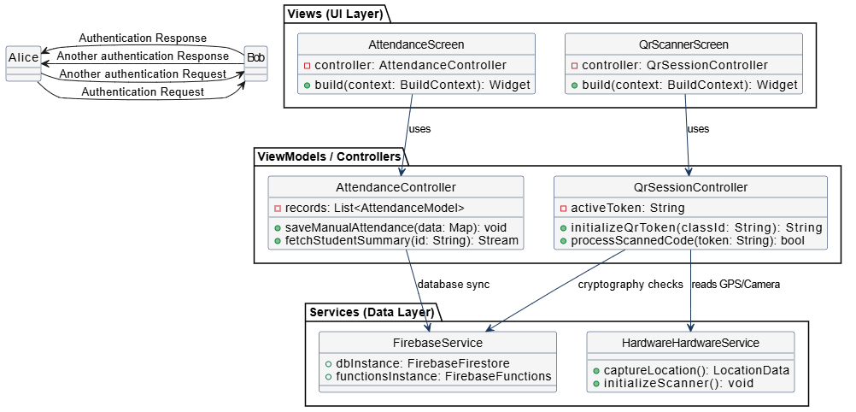

1.5.2. Sequence Diagram (QR Scan Verification Flow)
This diagram maps out the sequential execution sequence when a student processes a dynamic, time-limited validation code:
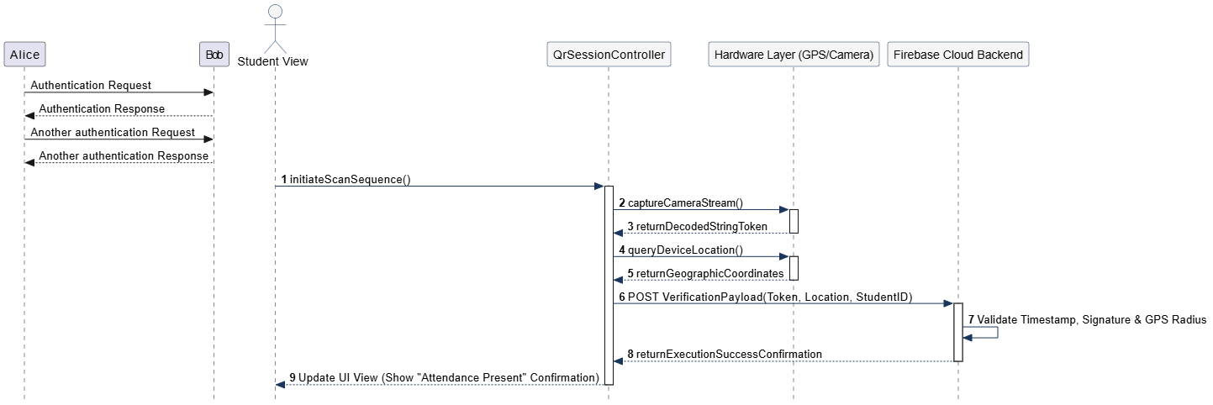

1.6. Coding Conventions & Standards
The system enforces strict compliance with official Google Dart layout rules:
- PascalCase: Reserved for declaring classes, models, and type definitions (e.g., AttendanceController, StudentModel).
- camelCase: Utilized for declaring method instances, class fields, tracking pointers, and localized variables (e.g., saveManualAttendance(), currentSectionId).
- snake_case: Dictated exclusively for setting backend database collection structures, field maps, and disk directory filenames (e.g., attendance_sessions, student_id).
- Structural Safety: No interface layout may implement direct functional workflows; all backend mutations must run through explicit try-catch blocks wrapped in async controllers to handle potential drops in cellular connectivity gracefully.

2. Data Model Schema

2.1. Database Design Strategy (NoSQL Firestore Overview)
The database structure leverages Cloud Firestore’s document-oriented architecture. The system stores database records inside centralized collections, using logical structural references to manage the hierarchy of university data: Department $\rightarrow$ Semester $\rightarrow$ Section $\rightarrow$ Students.
To maintain high data processing speeds, attendance interactions are broken down into root collection arrays linked together via relational identifiers. This avoids deeply nested sub-collections that could impact performance over long academic periods.

2.2. Data Entity Descriptions

2.2.1. Users Collection Schema
Tracks operational clearance values and profiles for all active system accounts.
- uid (String - Primary Key): Unique authentication hash produced by Firebase Identity Management.
- email (String): Official institutional email mapping string (e.g., username@iub.edu.pk).
- role (String): Defines system operational access privileges; constrained to "admin", "teacher", or "student".
- name (String): Full display name of the account profile holder.

2.2.2. Sections Collection Schema
Defines institutional groupings to organize the student body.
- section_id (String - Primary Key): Distinct alphanumeric key indicating class year and track (e.g., cs-2023-it-m1).
- department (String): The parent academic office (e.g., "Faculty of Computing").
- semester_number (int): The active term index (e.g., 6).
- enrolled_students (Array of Strings): List of foreign keys mapping back to uid records in the users collection.

2.2.3. Attendance_Sessions Collection Schema
Tracks individual class tracking events initiated by teachers.
- session_id (String - Primary Key): Automatically generated tracking hash for an individual class session.
- section_id (String - Foreign Key): Links directly back to the target index in the sections collection.
- teacher_id (String - Foreign Key): Maps back to the users entry of the instructor who verified the session.
- date (String): Calendar reference string formatted uniformly as YYYY-MM-DD.
- period_number (int): Identifies the specific schedule block (e.g., 1, 2, 3).
- type (String): Defines the validation method used: "manual" or "qr".

2.2.4. Attendance_Records Collection Schema
Captures the discrete attendance state for individual students linked to active sessions.
- record_id (String - Primary Key): Unique document identifier for an individual attendance entry.
- session_id (String - Foreign Key): Relates the record directly back to the parent attendance_sessions instance.
- student_id (String - Foreign Key): Identifies the target student by mapping back to their user uid.
- status (String): The attendance value assigned: restricted to "present" or "absent".
- marked_at (Timestamp): The exact system time the record was committed, useful for tracking compliance.

2.3. Entity Working Properties & Relationships
The system maps structural interactions using explicit relational logic within the NoSQL database:
- The connection between sections and student users represents a Many-to-Many (M:N) relationship managed by array listings. This allows multiple students to occupy a single section partition, while preserving an individual student's connection to their broader academic cohort.
- The structural mapping from sections to attendance_sessions follows a One-to-Many (1:N) mapping. A single section container can generate multiple attendance tracking instances over an academic year.
- The relationship between attendance_sessions and its corresponding attendance_records uses a strict One-to-Many (1:N) transactional design. Every active tracking session must verify a matching array list of student records, but an individual record cannot exist outside the scope of its parent tracking session.

2.4. Entity-Relationship (ER) / Schema Diagram
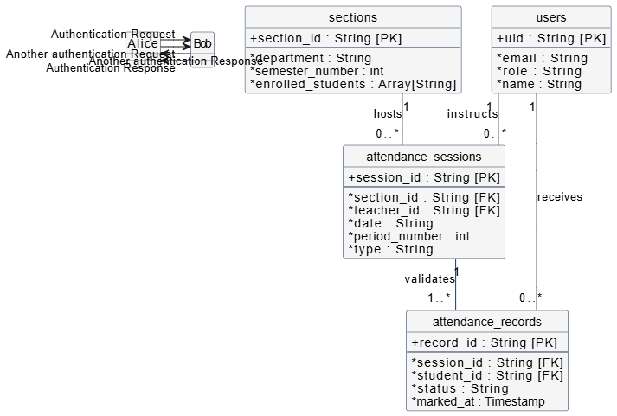

3. User Interface (UI) Design

3.1. Design Philosophy & Niche
The interface design strategy emphasizes a high-efficiency, role-optimized corporate utility dashboard built for fast use in busy classroom environments. The layout uses a premium card design with clear contrast boundaries to facilitate speed during manual grid updates or quick camera scanning workflows. The structural configuration limits multi-layered navigation pathways, ensuring teachers can initialize an attendance record or generate a QR code token in under three taps from the primary dashboard frame.

3.2. Visual Assets & Guide

3.2.1. Color Palette
The corporate visual language uses a combination of deep navy elements paired with clean academic highlights:
- Primary Corporate Contrast Identity (Deep Royal Blue): Used for primary application toolbars, screen selection cards, user identity headers, and main execution buttons (#1A365D).
- Premium Accent Frame (Academic Gold): Used for highlighting status items, active time-limited QR sessions, high-tier statistics, and important action items (#D4AF37).
- Neutral Screen Canvas Layout: Pure White (#FFFFFF) forms the background for all functional content cards, while Light Ivory Slate (#FAFAFA) provides clean separation across the underlying screen canvas.
- Operational Validation Flags: * Present State Emerald Green (#2E7D32): Highlights present status choices.
  - Absent State Dark Crimson (#C62828): Highlights absent status selections or session timeout warnings.

3.2.2. Typography & Fonts
To maintain fast widget rendering speeds across platforms, the interface relies on native system typefaces (Roboto for Android and SF Pro Text for iOS):
- Primary Dashboard Headers: Bold, 24pt, Deep Royal Blue (#1A365D).
- Sub-Section Class Metadata: Semi-Bold, 16pt, Slate Charcoal (#2C3E50).
- Student Name Records Label: Medium-Weight, 14pt, Neutral Gray-Black (#212121).
- Dynamic Metrics Numbers: Bold, 20pt, Academic Gold (#D4AF37).

3.3. Responsive Layout & Screen Size Constraints
Interface elements adjust fluidly across standard 5.5-inch to 6.7-inch mobile screens using percentage-based scaling frameworks.
- Input Adjustments: Form fields wrap layout components inside specialized scrolling frames (SingleChildScrollView). This automatically shifts text inputs upward when the native soft-keyboard opens, avoiding layout overlap bugs on student login views.
- Grid Scaling Rules: Manual checkbox lists and class section options dynamically expand their width limits based on active layout checks, ensuring text bounds do not wrap awkwardly or break layout containers on narrow phone screens.

3.4. Detailed Screen Layouts & Data Explanation

3.4.1. Sign In / Authentication View
Acts as the initial validation gateway for all user roles. The layout features the university's institutional identifier logo centered on the top axis, directly above stacked text fields for inputting an email address and entering password keys. A full-width primary button styled in Deep Royal Blue triggers the initial server-side authorization check.
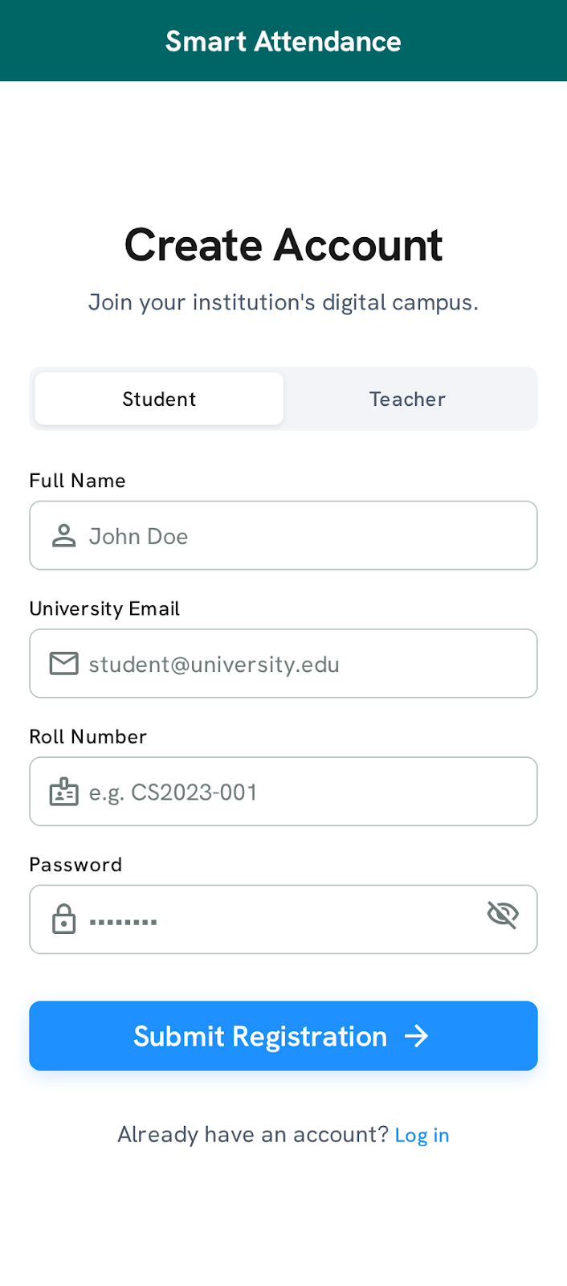

3.4.2. Teacher Dashboard Hub View
The main hub screen for instructors after a successful login workflow. The top section features a blue block displaying the teacher's profile alongside quick-action metrics (e.g., "Classes Today: 4"). The main body presents interactive options in a vertical list format, enabling instructors to choose between launching a "Manual Attendance Session" or initializing a "Dynamic QR Code Session".
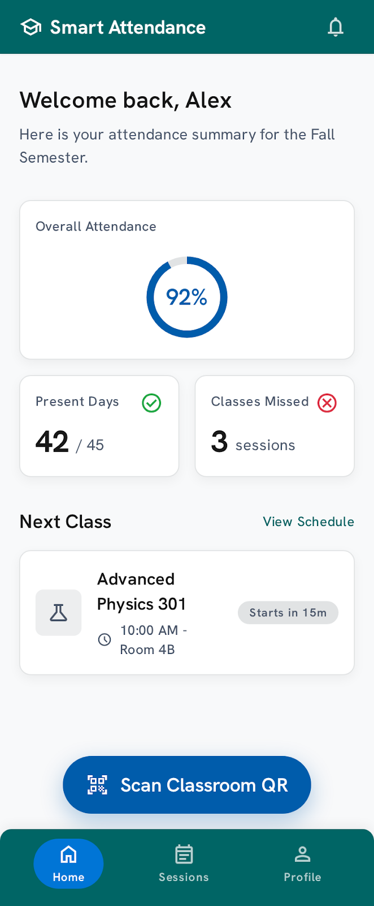

3.4.3. Manual Attendance Selection & Roster View
This layout assists instructors with manual roll calls. The header features dropdown selection menus to select the Target Department, active Semester Number, and Section ID. Once the section is chosen, the screen populates a clean vertical scrolling list card structure mapping the entire student roster. Each student row displays their name alongside a high-contrast toggle switch (Green for Present, Red for Absent). A persistent footer bar contains the "Save Attendance Session" button.
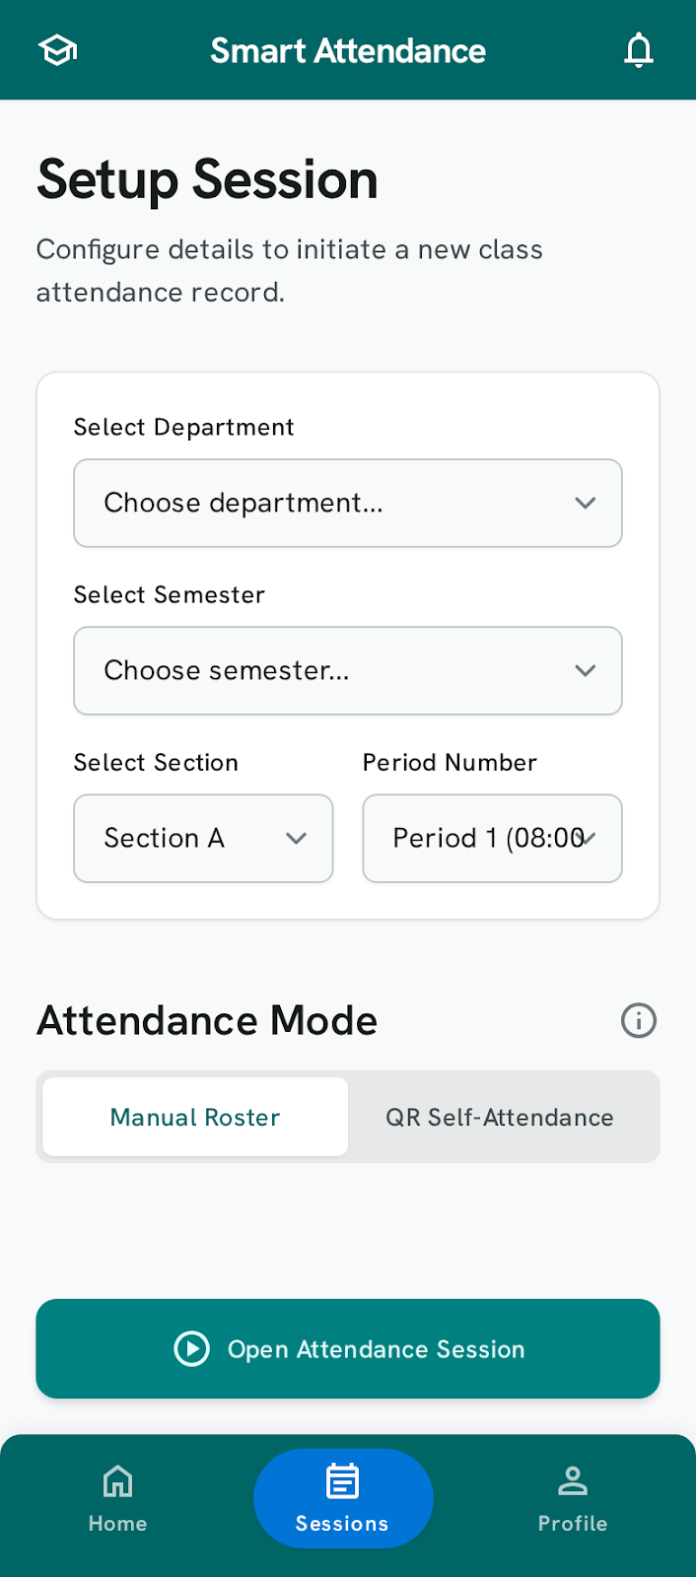

3.4.4. QR Generation Tracker View
Displays the time-limited QR code token generated on the server for automated attendance tracking. The screen features a white background layout with a large, high-contrast QR matrix code block centered on the viewport. Directly above the QR code, a countdown timer displays the seconds remaining before the token expires (highlighted in Academic Gold text). Below the QR code, text labels display the active Section ID and the designated Period Number.
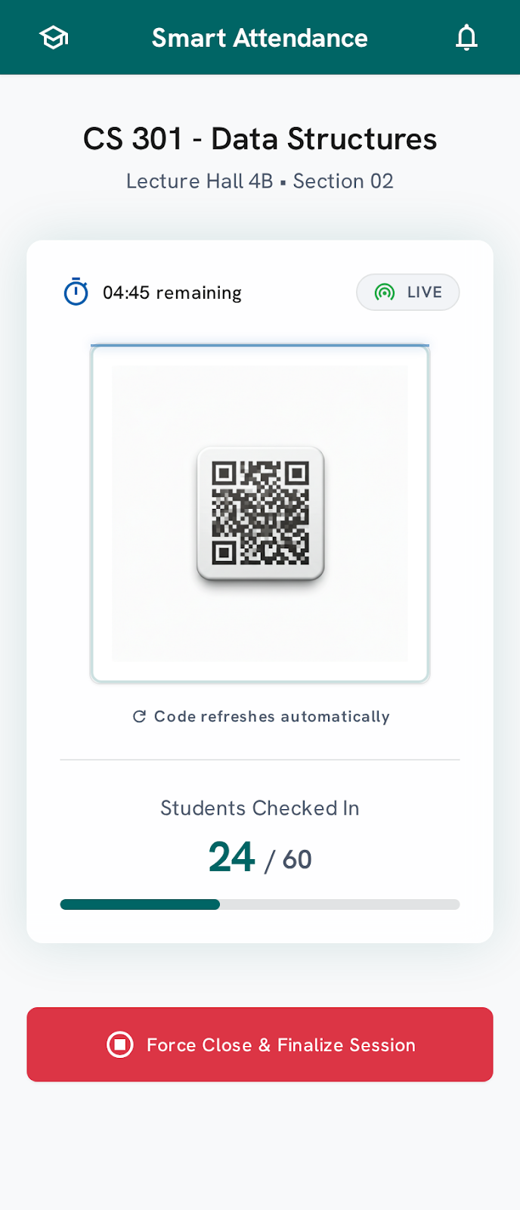

3.4.5. Student Dashboard Tracker View
The primary tracking screen for students, focusing on immediate clarity regarding compliance. The top section uses a large circular metric ring outlined in Academic Gold to show the student's Monthly Attendance Percentage (e.g., "88%"). The bottom half features a scrollable timeline container displaying past class dates, subject names, and period indexes, with each row explicitly marked as "Present" or "Absent".

3.4.6. Student Camera Scanner View
The functional interface used by students to scan the teacher's displayed QR code. It features a full-screen live camera view with a translucent royal blue square overlay targeting the scanning matrix field. A subtle notification banner at the base of the screen indicates active hardware connection loops, verifying that device GPS location checks are running concurrently.

